

# M.O.P. VAISHNAV COLLEGE FOR WOMEN (AUTONOMOUS)

CHENNAI-600 034

2019-2020

#### **PROJECT REPORT**

**SEMESTER – IV**

1813712080001

## REGISTER NUMBER:

# M.O.P VAISHNAV COLLEGE FOR WOMEN (AUTONOMOUS)

### CHENNAI-600 034

#### BONAFIDE CERTIFICATE

DEPARTMENT OF COMPUTER SCIENCE

## Certified Bonafide Record of Work Done

For Major Project during the year 2019-2020

Name of the Student : B.ABINAYA

1813712080001

Register number :

Date: Lecturer In-charge

#### Submitted for M.Sc. (Information Technology) Degree Project Evaluation at

M.O.P.VAISHNAVCOLLEGE FOR WOMEN (AUTONOMOUS)

CHENNAI – 600 034

Date: Examiners

**Skillset mapping of employee training management**

**Abstract:**

Skillset mapping of employee training management is an application developed for employees in the organization to access online course material. The project aims at creating a courses portal for an organization. This allows registered users of the system to join a course available in the application and access the materials published for the course. It facilitates to access the information of a particular course. The information is provided by the admin for a particular course. The purpose of developing this application is to provide training and enable the employees to gain extra knowledge in the interested domains of their choice.

**Introduction:**

Skillset mapping of employee training management is an web based portal developed at organizational level in ASP.NET. This project aims to furnish the skills of the employees that in turn helps the organization to develop and deliver successful projects. The primary objective of this project is to overcome the difficulties faced by the employees during offline trainings . The main modules of this application involves employee registration, course registration, Undergoing Course training, Providing feedback. The course trainings are completely based on the Skillset of the employees and the Discipline they belong to. The eligible courses are listed to the employees depending upon the Skillset and Discipline and they can register for any course. Once the course registration is done, the employees are provided with the course details. A certificate will be generated for the employees at the end of the training session. The goal of the project is to improve the efficiency of the employees to deliver successful projects.

**COMPANY PROFILE:**

**Combat Vehicles Research and Development Establishment** (**CVRDE**) is a laboratory of the [Defence Research and Development Organization](https://en.wikipedia.org/wiki/Defence_Research_and_Development_Organisation" \o "Defence Research and Development Organisation) (DRDO). Located in [Avadi](https://en.wikipedia.org/wiki/Avadi" \o "Avadi) , in [Chennai](https://en.wikipedia.org/wiki/Chennai), [India](https://en.wikipedia.org/wiki/India). It is the main DRDO lab involved in the development of [Armored fighting vehicles](https://en.wikipedia.org/wiki/Armoured_fighting_vehicle), [Tanks](https://en.wikipedia.org/wiki/Tank), Automotive electronics and many other.

**Areas of Work:**

CVRDE has been tasked with the design, development and testing of tracked combat vehicles and specialized tracked vehicles. It has also designed certain aircraft subsystems, mainly related to the engine and hydraulics. Like many DRDO labs, it also develops civilian technologies based on spin-offs of the defence related products developed by it. It has recently started developing Unmanned Ground Vehicles of the tracked category.

**Products and Projects:**

CVRDE is the main research lab responsible for the development of the [Arjun MBT](https://en.wikipedia.org/wiki/Arjun_MBT), 248 of which have been ordered by the Indian Army. It has also developed the [Tank-EX](https://en.wikipedia.org/wiki/Tank-EX), Bhim Self Propelled Artillery, based on the Arjun Chassis, and the Combat Improved Ajeya, an upgrade of the [Indian Army](https://en.wikipedia.org/wiki/Indian_Army)'s [T-72](https://en.wikipedia.org/wiki/T-72) Tanks.

Apart from these, CVRDE has also developed other combat and [Engineering Vehicles](https://en.wikipedia.org/wiki/Combat_Engineering_Vehicle), like Armoured Cars, Bridge-layer Tanks, Armoured Recovery Vehicles  and a Mortar Carrier based on the BMP-2 chassis.

CVRDE is also working on many technologies related to Armoured Fighting vehicles. CVRDE has a division dedicated to development of Automatic transmissions for Armoured Fighting Vehicles. It has developed transmissions of various power ranges viz. 1500, 800, 150 hp. It has developed various subsystems of transmission like torque converter, Fluid coupling and retarder, Steering units, Final drives etc. [Muntra](https://en.wikipedia.org/wiki/Muntra" \o "Muntra), India's first ever unmanned [armoured vehicle](https://en.wikipedia.org/wiki/Armored_vehicle) was developed here.

**Human Resource Division:**

This project is being carried out Human Resource Division of CVRDE .The department of Human Resource involves in providing training for the employees of the organization to furnish their skills which in turn helps the employees to develop and deliver successful projects. Trainings are based on the requirements of the employees, and the list of trainings are notified to the employees once the training details are published on the HRD PORTAL. One of the main objective of the HRD is to maintain the complete database of the employees who work in the organization.

**System Requirements:**

**Software Requirements:**

Operating system        : Windows 10

Coding Language         : ASP.NET MVC4

Tool                       : Microsoft Visual Studio 2010

Database                  : Oracle SQL Developer

**Hardware Requirements:**

RAM                 : 8GB

Processor : Intel core i3 processor

**Description of modules:**

In the project mainly there are 2 modules. They are

**Candidate module:**

The functionalities of the candidate include

-Registration

- Logging in/out

-Providing Basic details(Discipline , Skillset, Proficiency level)

- Course Registration

-Providing feedback

**Admin module:**

The functionalities of the administrator include

-Logging in/out

-Adding/Publishing a particular course

-Uploading pdfs for respective course

- Searching for the users who have registered for the particular course

-Reviewing feedback

**Candidate module:**

**Registration page:**  
 In the registration page , the registration of users will be performed. A unique id is given to each user. During registration user details will be validated, if a user already exists, system will notify the user(you have already registered).once the users are registered, they get full access to the application.

**Login screen:**

**User login:**  
 Through the login module, registered users can login. It is used for authenticating the users. After logging in, user can go for course based on their desired choice. When the user clicks login button, system will check for the entered values. If both values matches, user should be able to login, else system should generate “invalid user message”. This condition is being tested in login module.

**Candidate information page:**

This page contains technical information (Discipline, Skillset) of the registered users and is stored in the database.

**Course registration page :**

This page displays the list of courses that are eligible for the users with respect to the technical information(Discipline, Skillset) given by the user in the previous screen. The users can register for any course that is available. Once registered, the user gets full access to the course material provided by the administrator.

**Feedback page:**

The user provides feedback which is reviewed by the administrator.

**Admin Module:**

**Login Screen:**

The login module for admin contains username and password. Once the details are entered by the administrator ,it is validated and navigates the administrator to the admin screen, if the credentials are incorrect, the system will notify the administrator.

**Course Add Screen:**

This allows the administrator to add a list of courses with respect to discipline and skillset of the users. The course is added with the Discipline ,Skillset, Course title, course duration(from date, to date, due date)

**Uploading pdfs screen:**

This screen allows the administrator to upload the course material for each course. This course material is made available to the users once they are registered for the course.

**Viewing the registered users:**

The administrator has the ability to view the number of users who have been registered for a particular course with the help of the course title/name.

**Implementation and Software Description:**

Skillset mapping of employee training management is implemented by using ASP. NET MVC4 (Model, View, Controller)as the front end and Oracle SQL developer as the backend.

**Model-View-Controller(MVC): (Frontend)**

**ASP.NET MVC** is an open source web development framework from Microsoft that provides a Model View Controller architecture. ASP.net MVC offers an alternative to ASP.net web forms for building web applications. It is a part of the .Net platform for building, deploying and running web apps. You can develop web apps and website with the help of HTML, CSS, jQuery, JavaScript, etc.

The Model-View-Controller (MVC) architectural pattern separates an application into three main groups of components: Models, Views, and Controllers. Using this pattern, user requests are routed to a Controller which is responsible for working with the Model to perform user actions and/or retrieve results of queries. The Controller chooses the View to display to the user, and provides it with any Model data it requires. The following diagram shows the three main components and which ones reference the others:

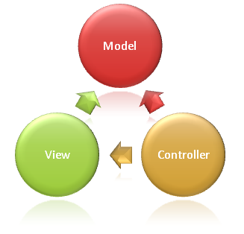

**Model Responsibilities:**

Model objects are parts of the application which implement the logic for the application's **data domain**. It retrieves and stores model state in a database.An MVC model contains all of your application logic that is not contained in a view or a controller. The model should contain all of your application business logic, validation logic, and database access logic

**View Responsibilities**

Views are responsible for presenting content through the user interface. . A view should contain only logic related to generating the user interface. There should be minimal logic within views, and any logic in them should relate to presenting content. If you find the need to perform a great deal of logic in view files in order to display data from a complex model, consider using a [View Component](https://docs.microsoft.com/en-us/aspnet/core/mvc/views/view-components?view=aspnetcore-3.1), View Model, or view template to simplify the view.

**Controller Responsibilities**

Controllers are the components that handle user interaction, work with the model, and ultimately select a view to render. In an MVC application, the view only displays information; the controller handles and responds to user input and interaction. In the MVC pattern, the controller is the initial entry point, and is responsible for selecting which model types to work with and which view to render (hence its name - it controls how the app responds to a given request).

The controller is responsible for controlling the way that a user interacts with an MVC application. A controller contains the flow control logic for an ASP.NET MVC application. A controller determines what response to send back to a user when a user makes a browser request.

**Oracle SQL Developer(Backend):**

Oracle SQL developer is implemented for the purpose of creating tables, procedures, triggers and sequences .It works as a backend in which all the user information will be stored and maintained.

**Advantages of ASP.NET MVC**

* Highly maintainable applications by default
* It allows you to replace any component of the application.
* Better support for Test Driven Development
* Complex applications are easy to manage because of divisions of Model, View, and Controllers.
* Offering robust routing mechanism with front controller pattern
* Offers better control over application behaviors with the elimination of view state and server-based forms
* .Net MVC applications are supported by large teams of developers and Web designers
* It offers more control over the behaviors of the application. It also uses an optimized bandwidth for requests made to the server

**Disadvantages of ASP.NET MVC**

* You can't see design page preview like the .aspx page.
* You need to run the program every time to see it's actual design.
* Understanding the flow of the application can be challenging
* It is quite complicated to implement, so it is not an ideal option for small level applications
* ASP.NET MVC is hard to learn, as it requires a great understanding of MVC pattern

**Data Flow Diagram:**

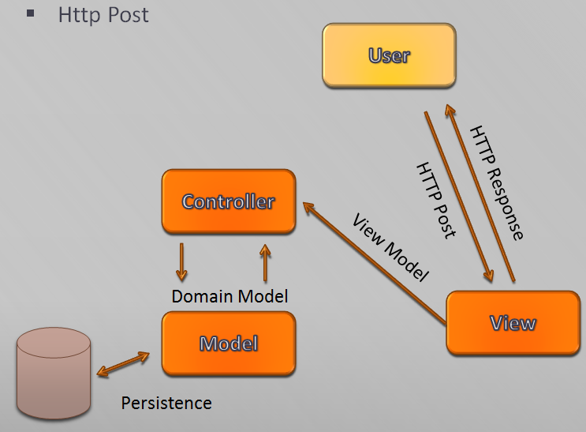

This explains how the data flows in the Model-View-Controller. Once the request is sent by the user, corresponding response is displayed with the help of View. From the view, the control is passed to the controller. The Model is used to fetch queries from the database as per the request and return it to the controller. The response is being sent to the view by the controller which in turn passes the response to the user.

**Use case diagram:**

**Candidate :**



**Admin:**



**Sequence Diagram:(Flow of events occurring in the project)**

candidate

login

candidate UI

database

admin

1. user registration (basic details)

2. submit

4. error message (incorrect details)

3. Enter login details

5. Enter correct details

6. Publish course

7. Register for course

8. undergo training

9. Provide feedback

10. Submit

11. Review feedback

12. Maintain database

13. Logout

**Working:**

The basic functionality of this web application is to enable the users to access the course material. The first step involves the registration of users . The details of the registered users are stored in the database. Once registered, the candidate (users)get full access to the web application. The candidates are required to provide the basic details (Discipline, Skillset and Proficiency level)in order to register for a particular course. The given details are mapped in the database and the eligible course list is provided in the candidate’s interface .The course list is provided with the Name of the Course ,Duration of the course(from date(start date of the course), to date(end date of the course), due date(deadline to register))and a Brochure is provided in pdf format which contains the syllabus /topics that are covered during the event of the course. A register button is provided with the each course, and the candidate can click on it if they wish to register for the course. After registration, the course material is made available for the candidates . This can also be downloaded by the candidates. Once the course duration is complete, a certificate is generated for the candidates .Finally the candidates provide feedback.

The administrator is in charge of maintaining the candidate’s database . The administrator’s login credentials are validated during login process. The courses are published by the administrator with Discipline, Skillset, course name, Duration of the course(from date(start date of the course), to date(end date of the course), due date(deadline to register))and a Brochure which are made available to the candidate when they are registered, also the course material is uploaded accordingly. The main objective of the administrator is to validate the details given by the user and throw error messages if they are incorrect .Finally ,the admin reviews the feedback provided by the candidates.

**Testing:**

* Testing is a process of executing a program with the intent of finding an error.
* Testing techniques performed in this project as follows:

**Functionality Testing**

-Verifying there is no dead page or invalid redirects.

-First checking all the validations on each field.

-Wrong inputs to perform negative testing.

-Verifying the workflow of the system.

**Usability testing**

**-**To verify how the application is easy to use with.

-Test the navigation and controls.

-Content checking.

**Interface testing**

**-**Performed to verify the interface and the dataflow from one module to other.

**Screenshots:**

**Homepage**:

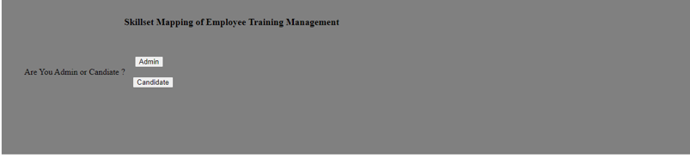

This page demonstrates the separation of modules, i.e either admin module or candidate module.

**Candidate Module:**

1.

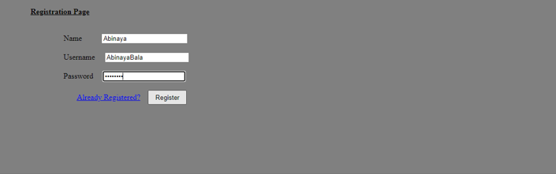

The registration of users is done in this page with the name, username and password of the users which is stored in the database.

2.

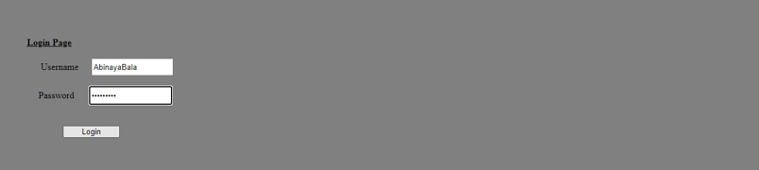

This is the page where the user’s/candidate’s credentials are validated in order to allow them for the course registration.

3.

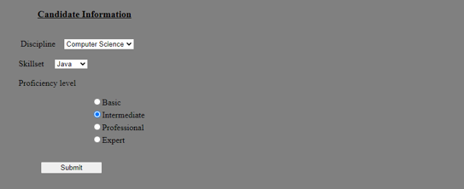

In this page, the technical details of the candidates are given. Once the details are

submitted, they are mapped and the eligible course list is provided to the candidates .

4.

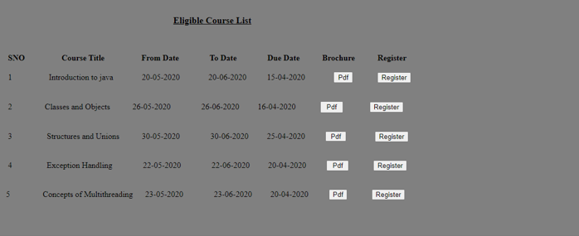

The list of eligible courses are provided to the candidates. As shown, courses are provided with the start date of the course ,end date of the course and the deadline date to register for a particular course. A brochure is also provided in order to make the candidates know about the topics that are covered. Once the register button is clicked , the candidates gets registered for the course.

5.



Once registered, the candidates gain full access to the course material. They can also download the course material for future reference.

6.

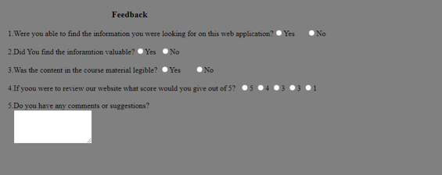

The feedback is provided here by the candidate which can be reviewed by the administrator.

**Admin module:**

1.

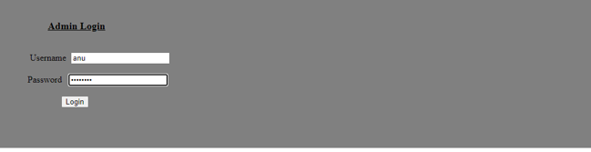

In this page , the credentials of the administrator is being validated. If the credentials are correct ,the

functionalities of the admin can be performed. If incorrect ,an error message is thrown stating “Invalid “.

2. 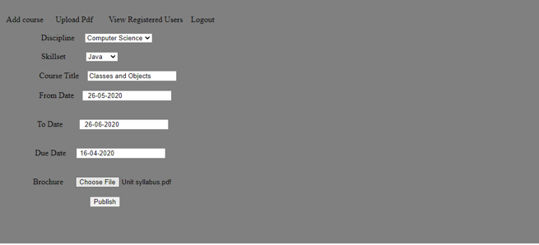

This page demonstrates on how a course is being published by the administrator.

3.



In this page ,the administrator uploads the course material with respect to the title of the course.

4.

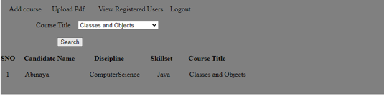

This page displays the list of candidates who have been registered for a particular course. This functionality is performed by giving the name of the course and retrieving the details of the candidate.

**Conclusion:**

Skillset Mapping of employee training management provides an overview of how course training is provided to employees in an organization. This Project has been developed to improve the efficiency of the employees ,so as to develop and deliver successful projects to the organization. The future work of this project will be to embed videos into the application and provide more interactive sessions for the employees.

**References:**

* 1. <https://dotnet.microsoft.com/apps/aspnet/mvc>
  2. <https://en.wikipedia.org/wiki/Combat_Vehicles_Research_and_Development_Establishment>
  3. <https://www.google.com/search?q=testing+web+application&rlz=1C1CHBF_enIN876IN876&oq=testing+web+application&aqs=chrome..69i57.6950j0j7&sourceid=chrome&ie=UTF-8>
  4. <https://www.google.com/search?q=dataflow+diagram+of+view+passes+to+controller&rlz=1C1CHBF_enIN876IN876&hl=en&sxsrf=ALeKk00zeCFvhcmPCn2pnKKzUpFr6KqUhw:1593882483380&source=lnms&tbm=isch&sa=X&ved=2ahUKEwjn7_D5irTqAhVFfH0KHaeMCmAQ_AUoAXoECA4QAw&biw=1366&bih=625>
  5. <https://www.guru99.com/asp-net-mvc-tutorial.html>